TARGETFISH

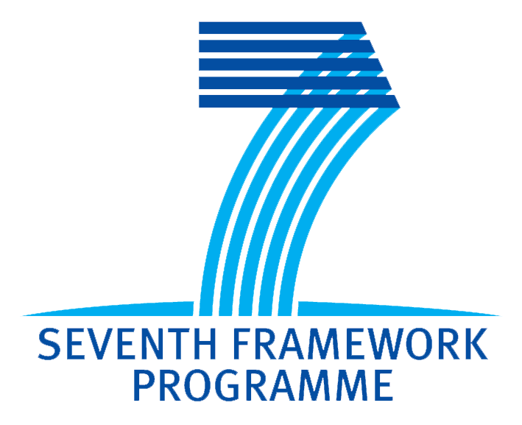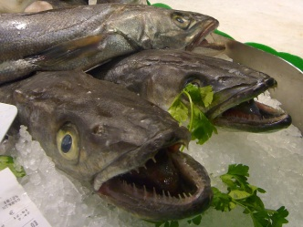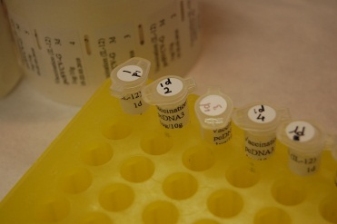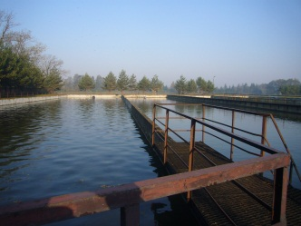

TARGETFISH - Targeted disease prophylaxis in European fish farming
TargetFish is a large collaborative project to be funded with 6 million euro by the European Commission 7th Framework programme (grant agreement no. 311993). The project will run for 5 years starting 1st October 2012. TargetFish, coordinated by dr. Geert Wiegertjes (Department of Animal Sciences, Cell Biology & Immunology group) brings together leading European research groups that are experts on the fish immune system and enterprises from the Biotech and Veterinary sectors that aim to commercialize fish vaccines for European fish farming.
Background European aquaculture production provides direct employment to 65.000 people with a turnover of 3 billion €. However, the lack of authorised veterinary medicinal products and the consequent disease outbreaks in farmed fish species costs the sector 20% of the production value. The most appropriate method for disease control, both on economical and ethical grounds, is disease prevention by vaccination.
Aim TargetFish will advance the development of existing (but not sufficient) and new prototype vaccines against socio-economically important viral or bacterial pathogens of Atlantic salmon, rainbow trout, common carp, sea bass, seabream and turbot. TargetFish will also establish a knowledge- and technology-base for rational development of next generation fish vaccines. The project will develop targeted vaccination strategies for currently sub-optimal and for novel vaccines. Improved vaccines will be brought closer to industrial application by addressing practical issues such as efficacy, safety and delivery route.
Main objectives TargetFish will 1) generate knowledge by studying antigens and adjuvants for mucosal routes of administration while analyzing the underpinning protective immune mechanisms; 2) validate this knowledge with response assays for monitoring vaccine efficacy and study safety aspects, including those associated with DNA vaccines; 3) approach implementation of prototype vaccines by optimizing vaccination strategies thus 4) shortening the route to exploitation. Thereby, this project will greatly enhance targeted disease prophylaxis in European fish farming.
Partnership To achieve these challenging tasks, we brought together 30 partners from 10 EU member states, 2 associated countries and 1 International Cooperation Partner Country (ICPC). In this large multidisciplinary consortium an approximate equal number of RTD and SME partners will cooperate closely while keeping an intensive communication with the large vaccine and nutrition industries via an Industry Forum.

Partners
- Wageningen Universiteit (WU), The Netherlands – dr. Geert Wiegertjes (Coordinator)
- Danmarks Tekniske Universitet (DTU), Denmark – dr. Niels Lorenzen
- The University Court of the University of Aberdeen (UA), United Kingdom – dr. Chris Secombes
- The Scottish Ministers Acting Through Marine Scotland (MS), United Kingdom – dr. Bertrand Collet
- Friedrich Löffler Institut - Bundesforschungsinstitut Für Tiergesundheit (FLI), Germany – dr. Uwe Fischer
- Instituto Nacional De Investigacion Y Tecnologia Agraria Y Alimentaria (INIA), Spain – dr. Carolina Tafalla
- Universitat Autonoma de Barcelona (UAB), Spain – dr. Oriol Sunyer
- Universita Degli Studi Della Tuscia (UT), Italy – dr. Giuseppe Scapigliati
- Institut National De La Recherche Agronomique (INRA), France – dr. Pierre Boudinot
- Norges Veterinaerhogskole (NV), Norway – dr. Øystein Evensen
- The University Of Stirling (US), United Kingdom – dr. Alexandra Adams
- Istituto Zooprofilattico Sperimentale delle Venezie (IZSV), Italy – dr. Calogero Terregino
- Københavns Universitet (KU), Denmark – dr. Kurt Buchmann
- Výzkumný ústav veterinárního lékařství (VRI), Czech Republic – dr. Tomás Vesely
- The Hebrew University of Jerusalem (HUJ), Israel – dr. Lior David
- University of Murcia (UM), Spain – dr. Victoriano Mulero
- Tethys Aquaculture Limited (TET), Greece – dr. Patrick Smith
- PatoGen Analyses AS (PG), Norway – dr. Vidar Aspehaug
- Fishlab (FL), Denmark – dr. Kirsten Engell-Sørensen
- Naxo OÜ (NX), Estonia – dr. Juri Sober
- Ridgeway Biologicals (RBL), United Kingdom – dr. Tim Wallis
- Rossi A/S (ROS), Denmark – dr. Torben Rød
- Ingeniatrics Tecnologias S.L. (ING), Spain – dr. Maria Flores
- BigDNA (BD), United Kingdom – dr. John March
- W42 Industrial Biotechnology GmbH (W42), Germany – dr. Ansgar Stratmann
- P.Christofilogiannis - I.Tavla O.E (AQ), Greece – dr. Panos Christofilogiannis
- CentroVet (CV), Chile – dr. Jaime Tobar
- Dansk akvakultur forening (DA), Denmark - dr. Niels Henrik Henriksen
- BioMar A/S (BM), Denmark – dr. Anne Hjørngaard Larsen
- Bionaturis (BN), Spain – dr. Victor Infante

Contact
Targetfish.cbi@wur.nl

