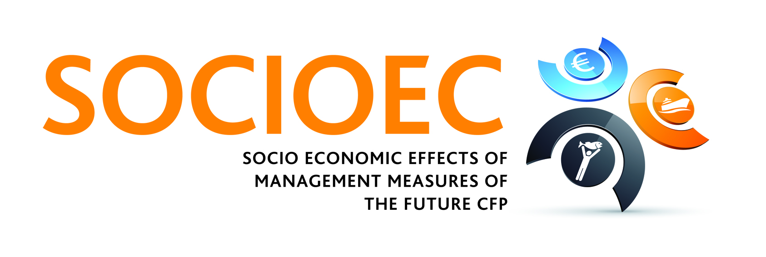

Working on the future management of European Fisheries
[Release Date: 30-April-2012]
Over the next 3 years a new pioneering €3 million research project called SOCIOEC, funded by the Seventh Framework Programme (FP7) of the European Union (EU) and led by the Institute of Sea Fisheries of the Johann Heinrich von Thunen-Institut (vTI), Germany, aims to respond to the challenge of the new management measures potentially applied in the context of reform of the new Common Fisheries Policy. SOCIOEC brings together a multidisciplinary consortium from 25 institutions (research, industry and SMEs) based across Europe guided by the ethos of maintaining the environmental, economic and social sustainability of European fisheries. The project kicked off with a partnership meeting in middle March 2012 in Salerno, Italy.
If the European fishing industry wants to survive and prosper in the 21st century, there is a need of a fisheries management system that can help bring the economic interests of the sector back into line with society’s long-term interest in healthy seas and thriving fish stocks. This is the scope of the new Common Fisheries Policy (CFP), which will enter in force in 2013. SOCIOEC project aims to provide a mechanism for developing management measures that are consistent with the overarching sustainability objectives of the EU, and provide a consensus across all stakeholders.
The Project Coordinating team led by Dr. Ralf Doering stated “SOCIOEC will focus on the interpretation of overarching (EU) objectives in local and regional contexts. There is a need to translate EC requirements, consistent with the aims of the new CFP, the Marine Strategy Framework (MSFD) and other EU directives, so that are understandable by the wider stakeholder community and engage their support. We will analyse a range of available, emerging and possible new management measures to overcome shortcomings of fisheries management still unresolved, and will consider their implementation on a regional level”.
The social and economic complexity of the different European fisheries stocks is going to be addressed by dividing the project into fisheries study cases: Baltic and North Sea demersal, Mediterranean & Black Sea, Western Waters, Pelagic and Non-EU. In each study case the environmental, social and economic realities of each area will be considered as well as examining how to adopt future EU requirements into management measures suitable to the different fisheries.
SOCIOEC consortium includes economists, biologists and anthropologists. This interdisciplinary approach will guarantee the economic viability of the proposals as well as its biological sustainability and the most important the new potential management measures will rely on the agreement of the sector ensuring their implementation.
Note to Editors

The Institute of Sea fisheries, one of the 15 specialty institutes in which is divided the Johann Heirich von Institute, is the coordinator of the project with AquaTT as the project dissemination partner. The SOCIOEC project is funded by the European Union's Seventh Framework Programme for Research and Technological development (FP7/2007-2013) under the grant agreement n° 288925.

Note to Editors

Dr Ralf Doering, SOCIOEC coordinator, is leading the fisheries economics unit at the Institute of Sea Fisheries at Johann Heinrich von Thünen (vTI-SF), and has worked mainly on the implementation of the ecosystem-based-approach to fisheries management plans and the evaluation of long term gains compared to shore term costs.

vTI-SF is one of the 15 specially institutes in which the Johann Heinrich von Thuenen-Institut is divided. The vTI-SF prepares decision support for the German Federal Ministry of Food, Agriculture and Consumer Protection (BMELV) with respect to the CFP and international marine conventions of which Germany is member. Through its scientific monitoring programs and research activities, the institute contributes to general increase in knowledge about ecology and economy of marine systems, enunciates advice to the European Commission, and provides a significant part of the German contribution to the advice of fisheries and marine ecosystems under the auspices of the International Council for the Exploration of the Sea (ICES).

Detailed partner profiles are available on request.

For press queries, please contact the project communication officer:
Federico Cardona Pons, AquaTT (email: federico@aquatt.ie Tel: +353 1 644 9008)
AquaTT staff are able to respond to queries in English, French, Spanish, Italian and Dutch.

