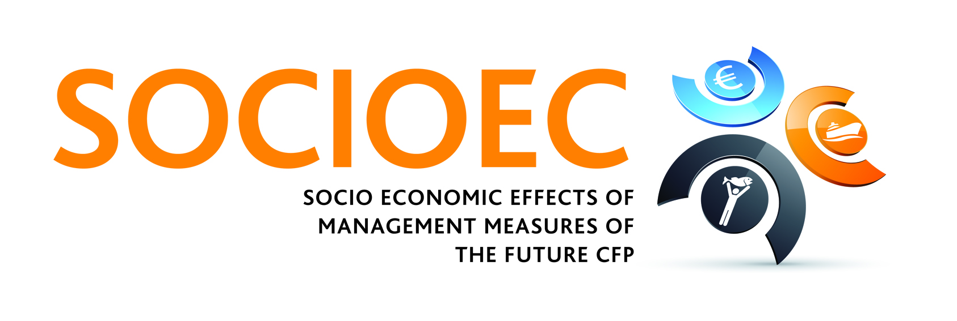

SOCIOEC Methodology Workshop
[Release Date: 24-10-2012]
The SOCIOEC project held a methodology workshop on the 26th September 2012 in The Hague (The Netherlands). During the workshop, which took place at the Landbouw Economisch Instituut (LEI), project partners discussed possible methodologies to be used in the six case studies involved in SOCIOEC. The participants discussed the input needs required to deal with sustainability objectives, management incentives (including fishers’ behavioural responses to these incentives) and the governance structures related to the current and future Common Fisheries Policy (CFP). These three issues form the core focus of the SOCIOEC project. The workshop included plenary sessions and case study-specific sessions. Representatives from the case studies identified methodologies designed to increase stakeholder involvement.
Ralf Dӧring, the project coordinator, outlined the importance of organising this methodology workshop. “Much of the success of the project depends on stakeholder engagement and involvement. Over the course of this workshop we have presented different methodologies such as focus groups or semi-structured interviews, which will allow the different SOCIOEC case studies to maximise their interaction with fishermen and benefit from the feedback they receive."
The SOCIOEC project is divided into six different case studies based on the Regional Advisory Councils (RAC) in which European waters are divided. The SOCIOEC case studies are Baltic Sea, North Sea, Mediterranean Sea, Western Waters (Atlantic), Pelagic fisheries and Non-EU fisheries. Although each case study is expected to achieve the general objectives of the SOCIOEC project, each has its own characteristics and specific objectives that will be addressed under the aegis of the project. The project's overall objective is to develop a list of future management measures that overcome the identified failures of the Common Fisheries Policy.
Birgit de Vos is leading Work Package 3 of the project, which is dealing with management incentives and fishers’ behavioural responses. She believes that each case study should choose the methodology best suited to achieving its aims. “The decision to select effective stakeholder involvement methodologies such as focus groups, semi-structured interviews or choice experiments depends on the specific needs of each case study. We have to choose the most suitable methodology that will generate comprehensive results on a case study-by-case study basis."
The SOCIOEC is an interdisciplinary project bringing together fisheries economists, social scientists and biologists with industry partners and other key stakeholders. The SOCIOEC project was launched in April 2012 and is going to work on solutions for future fisheries management that can be implemented at a regional level for the following three years.
For more information visit the SOCIOEC webpage www.socioec.eu.

Note to Editors
The Institute of Sea Fisheries at Johann Heinrich von Thünen Institute (vTI-SF) is coordinating the project. AquaTT is the project dissemination partner. The SOCIOEC project is funded by the European Union's Seventh Framework Programme for Research and Technological development (FP7/2007-2013) under the grant agreement n°289192.

The Landbouw Economisch Instituut (LEI) is the main institute for socio-economic research in agriculture, horticulture, and fisheries in the Netherlands. It has a staff of over 300 and is part of the Wageningen University and Research Centre (WUR).

Dr Ralf Dӧring, SOCIOEC coordinator, is leading the fisheries economics unit at the Institute of Sea Fisheries at Johann Heinrich von Thünen (vTI-SF) and has worked mainly on the implementation of the ecosystem-based approach to fisheries management plans and the evaluation of long term gains compared to shore term costs.

Birgit de Vos has been working for LEI since 2002 where she has carried out field and desk research on socio-economic issues and sustainability in Dutch fisheries. Birgit holds a PhD on fisheries governance and changing trust relationships between the main actors in the Dutch fishing industry.

Detailed partner profiles are available on request.

For press queries, please contact the project communications officer:
Federico Cardona Pons, AquaTT (email: federico@aquatt.ie Tel: +353 1 644 9008)
AquaTT staff members are available to respond to queries in English, French, Spanish, Italian and Dutch.

