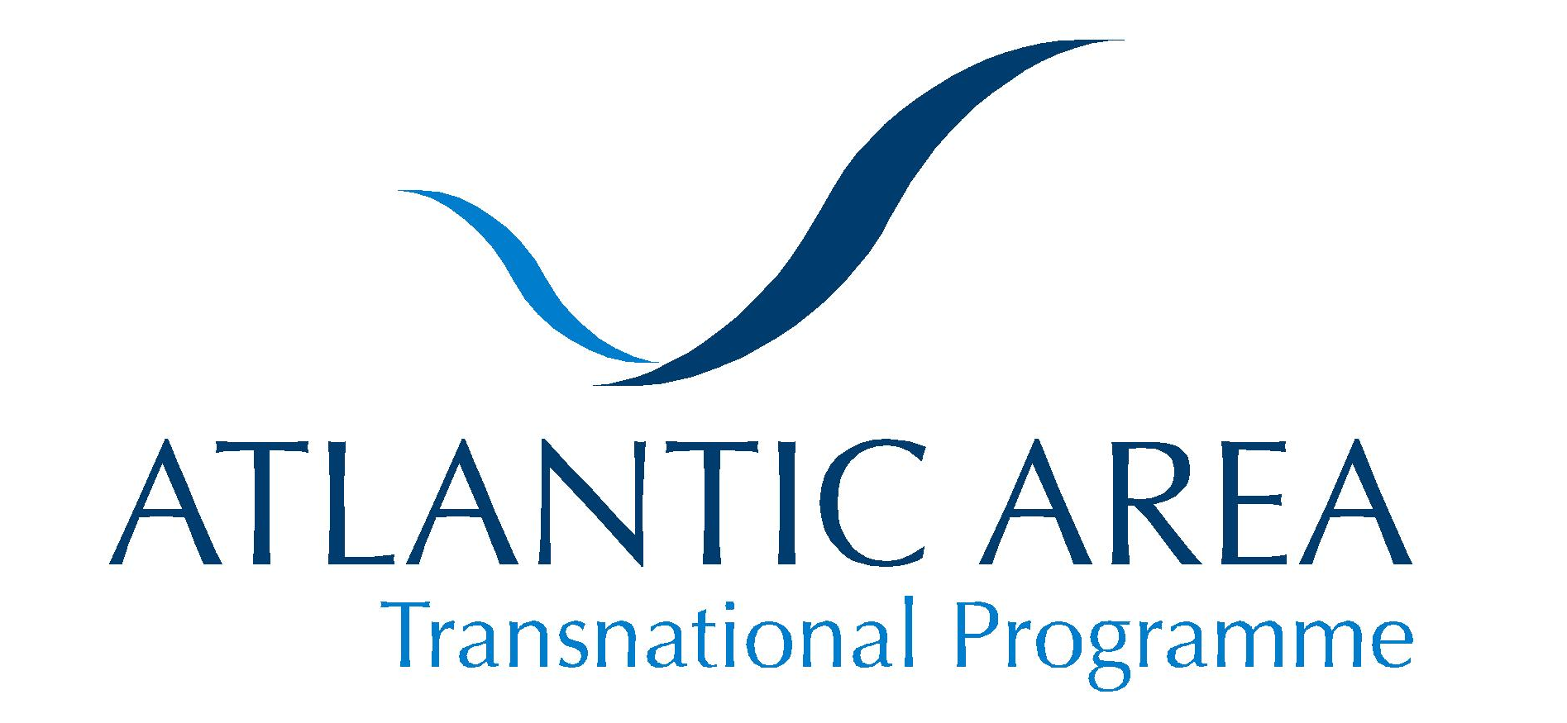 | 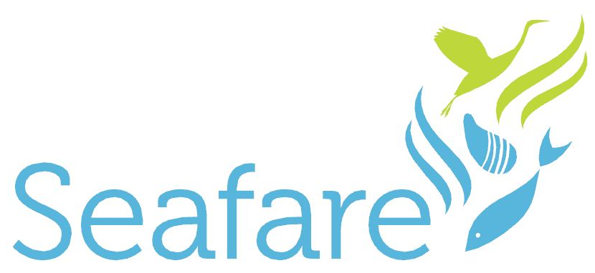

SUSTAINABLE & ENVIRONMENTALLY FRIENDLY AQUACULTURE FOR THE ATLANTIC REGION OF EUROPE

The aquaculture industry is an important contributor to the economic well-being of the Atlantic Area, particularly in rural peripheral areas. However, aquaculture in Europe must be developed in line with stringent EU rules which generate competition from other world regions, particularly Asia and Latin America.

The EU aquaculture sector has stagnated for the past seven years, in stark contrast to global growth of more than 6% in the same period of time. In order to reach its potential, the aquaculture industry must become more environmentally sustainable and address precautionary legislative actions.

In response to this, the European Union Atlantic Area Transnational Programme SEAFARE project has commenced. A productive kick-off meeting took place in Faro, Portugal in May, with the participation of all its committed partners. SEAFARE is designed to provide SMEs and public authorities with tools for sustainable and environmentally friendly aquaculture. It will strengthen links between researchers and industry, and influence policy development at regional and national levels. It will deliver innovative solutions for coastal zone management and the sustainable management of economic activity.

Project activities will promote alternative production options such as offshore systems. The protection of sensitive coastal environments and wetlands is fundamental, and can be achieved by integrating novel systems which minimise aquaculture discharge and which make use of natural biofilters. The partnership will also evaluate the issues associated with introducing aquaculture species, using Pacific Oysters as a model case study.

SEAFARE will add value, generating multidisciplinary synergies and transferring knowledge between researchers and industry, across the Atlantic Area. The goals and objectives of the project are well grounded and practical, and will lead to tangible results for SMEs, coastal policy makers, and environmental NGOs, among others.

If you would like to arrange an interview with members of the SEAFARE project team, please contact Mr Dan Lee, on +44 1248 388603 or email d.lee@bangor.ac.uk.

Ends 28 June 2010

Issued by AquaTT Limited & Bangor University, the SEAFARE project management team. For further information contact Dr Jon King, Project Manager, on +44 1248 713808 or j.w.king@bangor.ac.uk.

Note to Editors

Bangor University is the project coordinator of SEAFARE. Dublin-based AquaTT will function as the communication and knowledge management partner. The SEAFARE project has received funding from the European Union Atlantic Area Transnational Programme (2007-2013) under grant agreement n° 2009-1/123.

Detailed partner profiles are available on request.

