Interaction in European coastal waters: stakeholders give input to the COEXIST project

COEXIST is an EU Seventh Framework Programme (FP7) multidisciplinary project which will evaluate competing activities and interactions in European coastal areas. The goal is to provide a roadmap to better integration, sustainability and synergies across the diverse activities now taking place in the European coastal zone. In COEXIST, geographically diverse case studies will be considered, representing the conditions and combinations of activities in European coastal areas.

Stakeholder input is valued highly in the COEXIST project and at the latest project meeting (7-9 June 2011, Lisbon) several governmental institutions and aquaculture industries of the Iberian Peninsula had the opportunity to explain the main problems they encounter for running their activities in their coastal zones.

The COEXIST project is developing models that will help stakeholders in their decision making processes related to coastal zone management. The main strengths of these models are that they can be used to simulate different conditions (for example how a new policy will affect the system) but they can also calculate the best parameters for balancing competing activities and give advice on policy matters. The integration of the selected models is the key to help the decision process.

The project has also set up a consultation process which identified and clarified relevant stakeholders, their interrelationships and the mechanisms, mediums and levels of stakeholder engagement in the decision making process in each case study area. In addition, an institutional analysis has served to identify and clarify what Government departments and other regulatory agencies are involved in regarding the management of fishery and aquaculture activities in each case study area with a view to identifying potential areas of overlap, gaps or opportunities to streamline management requirements.

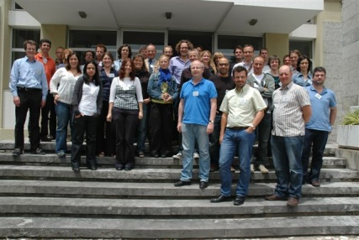 Photo: COEXIST project partners and stakeholders

Other interesting results so far include a description of the major present and future types of interactions between aquaculture and fisheries, or between any of these two elements and other sectors/resource users, accounting for spatial use, environment and ecology, and socio-economic factors, as well as an inventory of possible combinations of aquaculture and/or fisheries and other activities (existing and future scenarios), including a management tool glossary. These results will be made available on the COEXIST project website (www.coexistproject.eu) at the beginning of October 2011.

In addition, a first draft of the Framework for Multi-objective Quantitative and Qualitative Evaluation of Marine Spatial Management in Coastal Zones was presented and discussed. The application of this generic framework in each case study area will enable comparison among the case study results.

If you would like to arrange an interview with the COEXIST project team, please contact Emma Bello Gomez, to arrange a suitable time, on +353 (0) 1 475 8713 or email emma@aquatt.ie.

Ends 29 August 2011

Issued by AquaTT Limited & Institute of Marine Research (IMR), the Co-Exist project management team. For further information contact Emma Bello Gomez, Project Officer, on +353 (0)1 6449008 or email emma@aquatt.ie.

Note to Editors
IMR is the project coordinator of COEXIST, with AquaTT as its project management and communication partner. The COEXIST project has received funding from the European Union Seventh Framework Programme (FP7/2007-2013) under grant agreement n° 245178.

Detailed partner profiles are available on request.

