AQUAMED project seeks Mediterranean stakeholder input to build the Mediterranean Aquaculture Multi-Stakeholder Platform (MSHP)

AQUAMED, The Future of Research on Aquaculture in the Mediterranean Region, is an EU Seventh Framework Programme (FP7) project which aims to develop a cross-functional strategy for aquaculture research in the Mediterranean region. A multi-stakeholder platform will be set up to orchestrate research activities in order to promote the sustainable development of aquaculture in the region. Its aim is to rationalise research programming in order to avoid duplication and fragmentation of research efforts and to stimulate long-term cooperation and coordination across policy makers, the aquaculture industry and RTD performers in the Mediterranean region.

The third project meeting of the AQUAMED project was held in Rhodes (Greece), on the 17th and 18th of October 2011 coinciding with the EAS Conference “Mediterranean Aquaculture 2020”. All of the AQUAMED project partners were in attendance with several project observers also represented, including the European Aquaculture Society (EAS) and International Union for Conservation of Nature (IUCN). The aim of the meeting was to review the results obtained thus far, particularly in relation to the information collected by the main aquaculture stakeholders, research institutions and by the projects and to analyse the typology of each Mediterranean country participating in the project. The links between the AQUAMED project and the AQUAEXCEL EU FP7 funded project (Aquaculture Infrastructures for Excellence in European Fish Research) were examined in order to avoid any duplication of work and to define a cooperation strategy between both projects. The plan of action for the next six-month period was also discussed and approved.

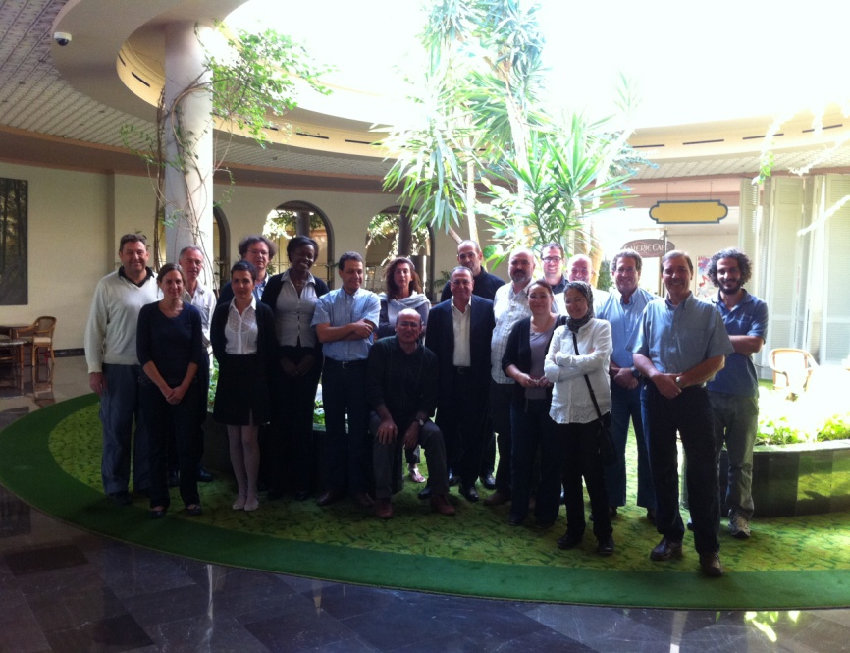
AQUAMED partnership

In order to take advantage of the attendance of prominent Mediterranean stakeholders at the EAS Conference “Mediterranean Aquaculture 2020”, the first meeting of the Mediterranean Aquaculture Multi-Stakeholder Platform (MSHP) was held on the 19th of October 2011. The main objective of this first meeting was to allow leading stakeholders to contribute to the establishment of the structure and operational concept of the MSHP. Seventeen stakeholders from six Mediterranean countries participated in this meeting. The discussion mainly focused on the preliminary thematic area list of the platform and the participants highlighted the importance in adapting this list to the particular needs and opportunities of the Mediterranean area. They emphasised that the main impact of the platform should be related to the technology and knowledge transfer, the successful collaboration between different stakeholders and the definition of priorities to avoid overlapping activities.

If you would like to more information about the AQUAMED project, please contact Marieke Reuver at +353 (0) 1 475 8713 or email marieke@aquatt.ie.

Ends 31 December 2011

Issued by AquaTT Limited, the AQUAMED dissemination project team. For further information contact Marieke Reuver, RTD Programme Manager, marieke@aquatt.ie

Note to Editors
IFREMER is the coordinator of this project on behalf of EFARO and AquaTT is its dissemination partner. The AQUAMED project has received funding from the European Union Seventh Framework Programme (FP7/2007-2013) under grant agreement n° 244999.

EFARO - The European Fisheries and Aquaculture Research Organisation is a non-profit organisation, created in 1989 in order to achieve greater cohesion and coordination of fisheries and aquaculture research. EFARO’s main focus is the delivery of new applied knowledge in the field of scientific support for policies in the European Community and associated States.

IFREMER is a public institute of an industrial and commercial nature that develops scientific expertise in the monitoring use and promotion of coastal seas, monitoring and optimising aquaculture products, promoting scientific advice in relation to resources for sustainable fishing, seafloor exploration and ocean biodiversity, forecasting ocean circulation, marine ecosystems evolution. It also manages vessels and underwater vehicles for the French scientific community. It has been involved for over 30 years in research in aquaculture and in the study of marine biology and aquatic ecosystems.

AquaTT is an international foundation which provides project management and training services to support the sustainable development of Europe's aquatic resources. AquaTT's mission is to bridge the knowledge gap between the dynamic R&D environments and the progressive commercial sector. AquaTT supports its target audiences through the provision of support services and through participation in, and coordination of EU projects and initiatives in the area of knowledge management including customised dissemination, education, training and technology transfer.

Detailed partner profiles are available on request.

