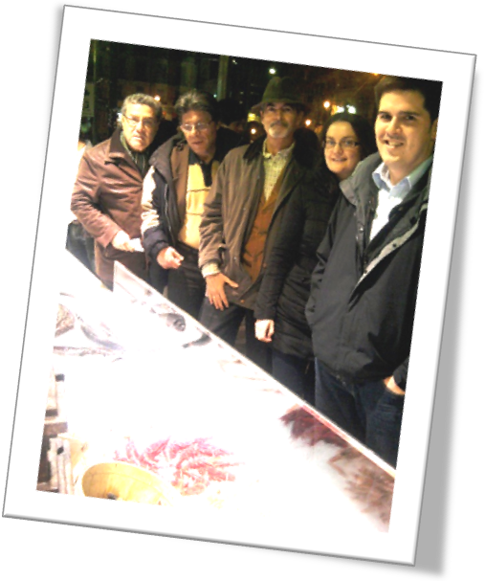
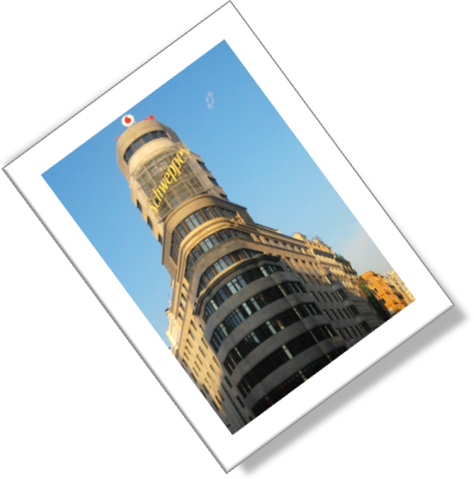
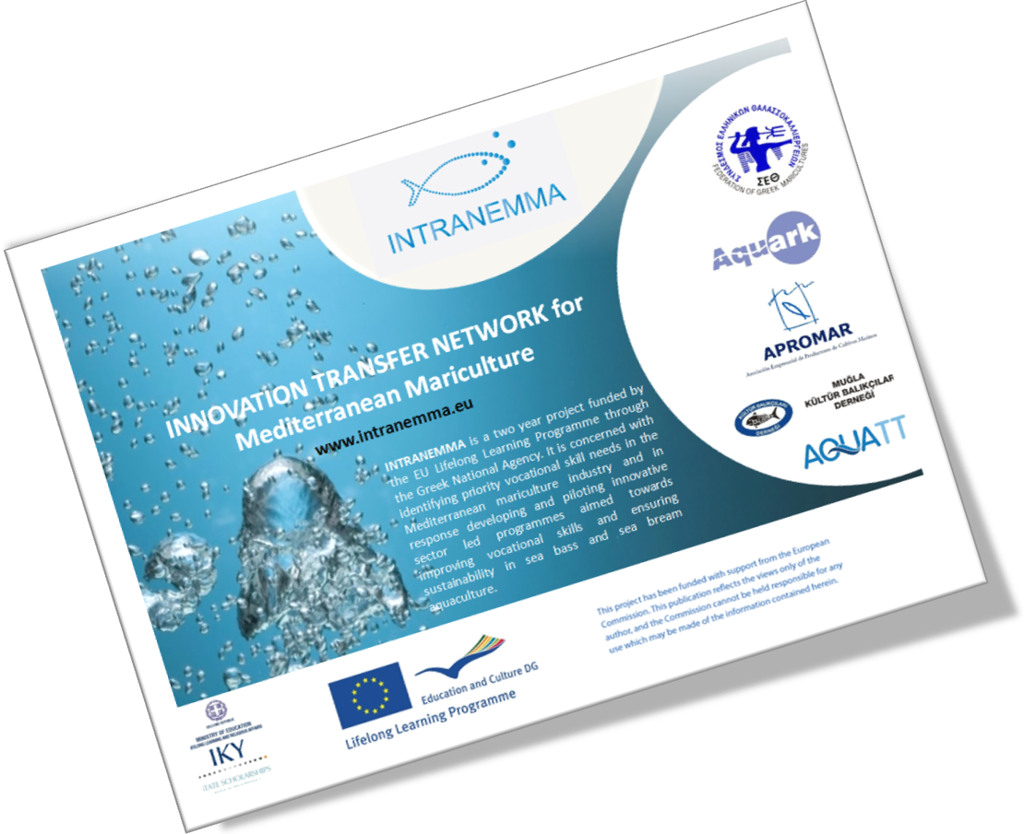
Second Partner Meeting
24-25th January 2012
Hotel Vincci Capitol, Madrid

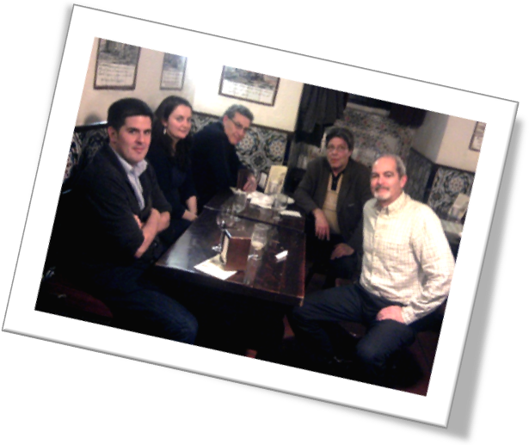
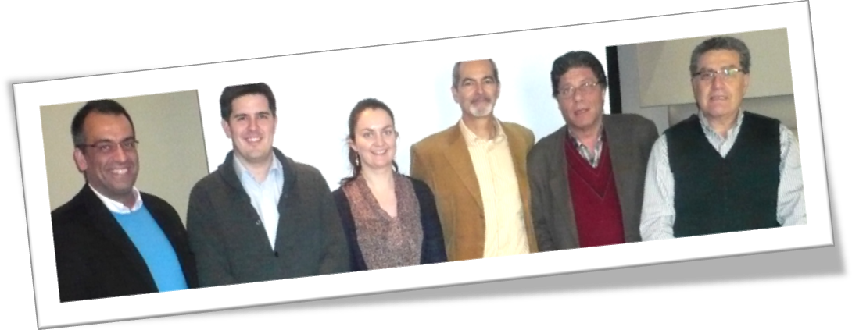

Innovation Transfer Network for Mediterranean Mariculture - INTRANEMMA
LdV Transfer of Innovation Project
Second Partner Meeting
24-25th January 2012 - Hotel Vincci Capitol, Madrid

INTRANEMMA is a two year transfer of innovation project that is the first of its kind to be developed by the Associations of Mariculture producers to identify areas where innovation is required and to design applied training courses to meet these needs.

Javier Ojeda, General Manager APROMAR (Spain), Akis Ventiris, FGM General Manager (Greece), Levent Kayi, Board Member of the Mugla Fish Farmers Association (Turkey) along with David Murphy, General Manager AquaTT (Ireland), Olivia Daly, Project Officer AquaTT (Ireland) and Panos Christofilogiannis, Managing Director AQUARK (Greece) met in Hotel Vincci Capitol in Madrid on the 24-25th January 2012 in the second partner meeting of the LdV Transfer of Innovation project INTRANEMMA (Innovation Transfer Network for Mediterranean Mariculture).

Partners audited the results of the INTRANEMMA survey and in depth interviews on the areas where innovation is required in Mediterranean Mariculture. They confirmed the plan of the INTRANEMMA training courses from June to November 2012 in order to maximize the dissemination of the training events and the impact on the Mediterranean Mariculture Industry. The training was selected not to be done during the summer since this is a very busy time for the industry.

In Turkey the training event will be held in parallel with the IZMIR Mariculture trade show Future Fish Eurasia 2012 on the 8th June 2012 (http://www.eurasiafairs.com/eng/index.html) to maximize the impact on the Turkish Mariculture sector.

The training in Turkey will be performed in parallel sessions for targeted audiences in:
- Innovative solutions in Processing technology and creation of added value products and services for sea bass and sea bream.
- Innovative solutions in Feeding Management and Vaccination strategies for sea bass and sea bream. This second theme will be the training course theme in Spain that will be held in Valencia on the 18th September 2012.

The training course in Greece will be a two day workshop held in Athens on the 11th and 12th of October 2012.
- The first theme will be: Innovative solutions in genomics applications for sea bass and sea bream and will be held in alliance with the FP7 project MG4U.
- On the second day (12th of October 2012) the theme will be: Innovative solutions in increasing predictability in sea bass and sea bream hatcheries and will be performed in alliance with the FP6 project FINEFISH and the European Aquaculture Technology and Innovation Platform.

The last INTRANEMMA event is planned for early November 2012 in Greece and will be an exclusive event for CEOs in the Mediterranean Mariculture value chain with the provisional theme: “How can Mediterranean Mariculture assume a leading role in Global Aquaculture?” The schedule of INTRANEMMA applied training courses for the industry is set to maximize impact and dissemination of scientific applied results, transferring technology in the areas identified by the industry as areas where innovation is required for sustainable development.

The INTRANEMMA consortium will also collate best practices on work safety conditions from APROMAR and FGM in order to develop guidelines that could be easily adopted across the Mediterranean. INTRANEMMA invites international experts with a special focus on the Mediterranean Mariculture to register in the project website and to participate in the working groups that will define the applied training material that will be delivered in the three main producing countries in Mediterranean Mariculture. Please follow the INTRANEMMA activities at www.intranemma.eu

