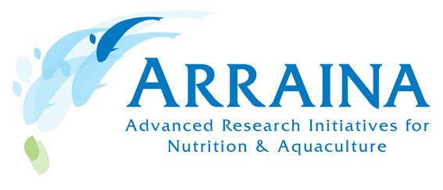

Major European Research Project Launched to help ensure a Sustainable European Aquaculture Sector
[Release Date: 16-03-2012]
Over the next 5 years a new pioneering €6million research project called ARRAINA, funded by the European Union (EU) and led by the Nutrition, Metabolism & Aquaculture Unit at St-Pee sur Nivelle, Aquitaine region of the National Institute for Agricultural Research (INRA), France, aims to respond to the challenge of the growing demand for fish by increasing the sustainability of farming fish by developing innovative vectors to supply alternative fish feeds that maintain the nutritional properties of the fish. ARRAINA brings together a multidisciplinary consortium from 21 institutes (research, industry and SMEs) based across Europe guided by the ethos of maintaining European aquaculture industry productivity while addressing the issues of nutritional value, food safety and environmental impacts. The project kicked off with a partnership meeting in late February 2012 at the INRA offices in Paris.
Traditionally, fish feeds are based on fishmeal and fish oil derived from capture fisheries, hence the sustainability and competiveness of aquaculture depends largely on the replacement of these with alternative ingredients such as plant-based feeds. ARRAINA will build on this by measuring the long-term effects these changes in diet will have on the full life cycle of fish for which presently little is known.
The Project Coordinating team led by Dr. Sadasivam Kaushik stated “By developing applied tools and solutions of technological interest in collaborations with SMEs, ARRAINA will further strengthen the links between the scientific community, the EU feed industry and other stakeholders and will contribute to increase the productivity and performance of European aquaculture sector helping to ensure competitiveness in a global market.”.
Looking at the five main European aquaculture species (Atlantic Salmon, Rainbow Trout, Common Carp, Gilthead seabream, European Seabass), the partners of ARRAINA from different leading scientific groups across Europe with their pioneering research and long-term approaches will define quantitative nutritional requirements for the target fish species, identify and develop integrative tools to accurately measure and predict growth responses, metabolic and health effects, investigate the long-term effects of alternative feeds on fish metabolism, performance, quality and waste management throughout the whole fish lifecycle (egg to brood stock), develop innovative novel delivery vectors for macro and micronutrients and dietary supplements and validate the concept of nutritional programming.
The European Commission's (EC) scientific officer for the project, Dr. Stamatis Varsamos, in a letter addressed to the consortium before the kick off meeting mentioned “The ARRAINA proposal has been selected following the evaluation, by independent experts, of several high quality proposals, for its high potential in advancing the state of the art, as well as, for the merits and experience of its partners and of the consortium as a whole, which both should contribute in achieving the ambitious objectives that have been set by the Work Programme 2011 of the EU's 7th Framework Programme for Research and Technological Development and are now embedded in the DoW of the project. Having the chance to be the scientific officer appointed by the EC for the follow up of the ARRAINA project, I would like to congratulate, on behalf of our service, the coordinator Dr S. Kaushik and the consortium for having successfully been through the evaluation process.”
ARRAINA will deliver farmers, industry and the scientific community improved and innovative methods, tools and concepts for fish nutrition that contribute to a knowledge based economy by developing applicable outputs including designing and delivering training courses in fish nutrition to increase research capacities and expertise, and bridge the gap between the scientific community and the commercial sector by undertaking problem-based research and enhanced knowledge transfer.
The alternative feeds tailored to meet the nutrient requirements of the target fish aim to improve the competiveness, employment, health and environment of the EU and candidate countries.

Note to Editors

For press queries, please contact the projects communication officer:
David Murphy, AquaTT (email: david@aquatt.ie, Tel: +353 1 644 9008)
AquaTT staff are able to respond to queries in English, French, Spanish, Italian and Dutch.

